From Hospitals to Handcuffs: Criminalizing Patients in Crisis
ADDENDUM REPORT: SPOKANE

Background
In May of 2020, Disability Rights Washington (DRW) released From Hospitals to Handcuffs: Criminalizing Patients in Crisis. This report looked at arrests of patients for assault in Seattle health care facilities over the course of a year. DRW found that the majority of these incidents involved patients in behavioral health crisis. Generally, the assault was minor and there was no visible injury to a victim. Arresting patients leads to sick people removed from care and instead put in jail for weeks or months, where they decompensate and have less access to treatment. Many of the criminal charges against these patients were ultimately dismissed precisely because their mental health is so compromised. Perhaps most notable, arresting and prosecuting these patients does not actually reduce the rates of workplace violence faced by health care workers.
In addition to the investigation into Seattle incidents, DRW also examined 49 patient incidents from six health care facilities in Spokane over the same time period. This addendum report focuses on DRW’s Spokane findings and should be read together with From Hospitals to Handcuffs.
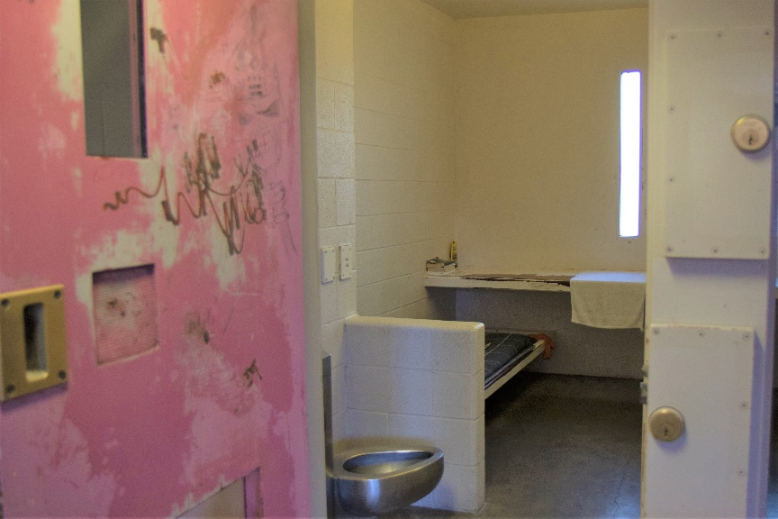
Photo of a solitary confinement cell in the Spokane County Jail
Like Seattle, Spokane engages in inhumane and ineffective criminalization of patients in crisis.
Many of DRW’s findings in Spokane mirrored those in Seattle. The majority of incidents in which Spokane health care staff called police involved patients in behavioral health crisis. Some patients were seeking emergency care while others were already admitted for inpatient psychiatric care, often involuntarily. Like in Seattle, the majority of Spokane patient arrests did not involve visible injury—only about 40% of arrests that resulted in criminal assault charges featured any visible injury to the victim.
The main determinative factor in whether Spokane police arrest these patients appears to be the wishes of the alleged victim. Spokane health care staff frequently told police that they wanted a patient arrested and charged and police generally complied—even when there was no visible injury, no imminent risk of harm, and the patient had clear behavioral health issues. In only four of the 49 incidents that DRW examined did a health care staff victim tell police not to arrest or pursue criminal charges against their patient. DRW identified six incidents in which police used their discretion to decline the wishes of the victim to arrest, and instead take a written report only. In these instances, the officer ensured that everyone was safe but also that the patient could continue to receive treatment and avoid jail. For example, a patient who was being involuntarily held for psychiatric treatment at Deaconess Hospital was trying to flee her hospital room. She bit a staff member, leaving a superficial mark. After police responded and evaluated the scene, an officer declined to arrest despite the victim’s wishes, stating: "Due to the minor injury and [the patient] being on the psychiatric hold I don't believe her level of culpability is high enough to charge her with the assault."
DRW found that the majority of the Spokane criminal cases filed against these patients did not result in guilty plea or conviction of the original assault charge. Many were ultimately dismissed—42% of felony cases and 62% of misdemeanor cases—and many of the dismissals were due to the patient’s mental health issues.
For example, a patient in the psychiatric emergency room at Sacred Heart stepped out of her room and began yelling at a nurse, accusing him of raping her in the past and hitting him in the face. Police arrested her and the County charged her with felony assault. After she was found not competent to stand trial, the County eventually dismissed her case months later.

In Spokane, Sacred Heart generated the vast majority of patient arrests.
Spokane’s Sacred Heart was responsible for the majority of the calls to police about patient assaults. Of the 49 incidents that DRW reviewed from six different facilities, Sacred Heart generated 26 of these police calls, 21 of which resulted in arrest of their patient. Deaconess Hospital generated 13 calls, nine of which resulted in patient arrest. The rest of the health care facilities DRW reviewed generated just a handful of incidents each.
Like Harborview in Seattle, Sacred Heart is unique in Spokane for having a psychiatric emergency room. It receives many of the Spokane patients in crisis and in need of behavioral health treatment. However, Sacred Heart saw 80% of its patient incidents result in arrest and removal from care, which was higher than Harborview.

Spokane pursues arrest and prosecution of patients in crisis more than Seattle, especially felony charges.
DRW found that Spokane police and prosecutors are not generally using their discretion to avoid unnecessary arrest and prosecution of patients in crisis. Unlike Seattle, Spokane police directly file misdemeanor criminal charges without allowing the city prosecutors to screen and decline charges. DRW believes that Spokane police are over-filing misdemeanor charges, as evidenced by the high rate of eventual dismissal for these cases. DRW found that once city prosecutors received the cases, they dismissed many of them due to the patient’s mental health issues. The Spokane police likely should not have filed those cases to begin with.
DRW also found that the majority of the Spokane incidents resulted in felony assault charges against patients, even for minor incidents with no visible injury. For example:
- Spitting on the back of a nurse’s pants
- Spitting on a nurse’s clothing and trying to kick the nurse without success
- Bumping a wheelchair into a nurse’s knee
- Elbowing a nurse in the arm but causing no injury
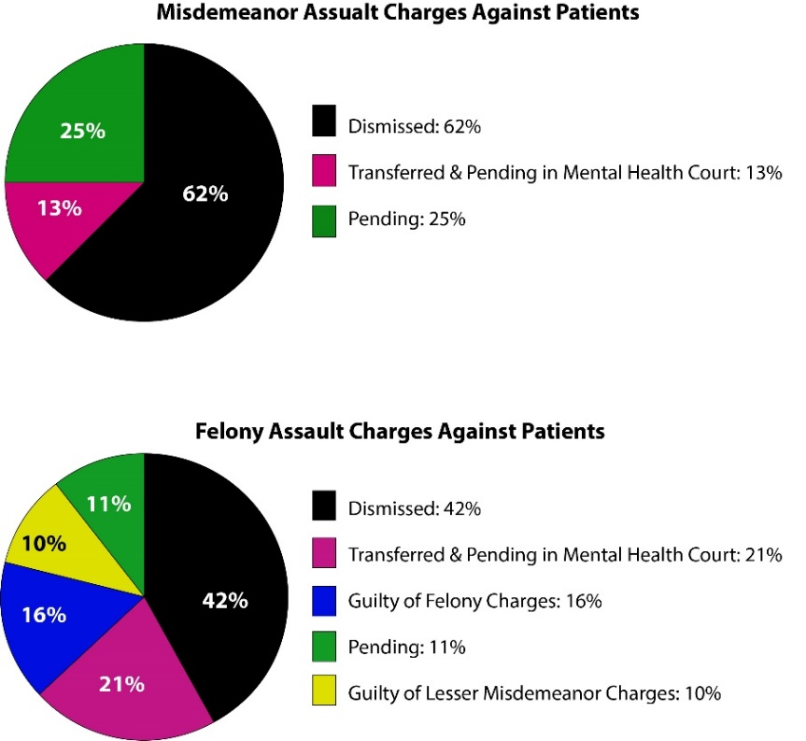
DRW believes the over-charging of felony assault against patients in Spokane is largely due to a lack of written charging guidelines for the Spokane County Prosecuting Attorney’s Office (SCPAO). In addition to promoting thoughtfulness and consistency in charging, written guidelines educate police on which cases are appropriate to refer for felony prosecution. SCPAO’s failure to maintain such guidelines contributes to misuse of the felony assault charge for patients experiencing behavioral health crisis. It is also worth noting that the SCPAO has received criticism in the past for incarcerating people at higher rates and having the highest rate of felony drug charges among Washington counties.

Recommendations
DRW’s investigation into Spokane found many of the same issues described in From Hospitals to Handcuffs, which shows that the criminalization of behavioral health conditions is not isolated to Seattle. This is all the more reason for health care facilities, law enforcement, prosecutors, and policy makers to implement all of DRW’s recommendations in From Hospitals to Handcuffs. Below, DRW provides additional recommendations specific to Spokane:
1) Sacred Heart should review its training and policies governing patient assault incidents and should work with its staff and with police to find better solutions.
In Spokane, Sacred Heart generates the vast majority of the incidents that lead to arrest of patients in crisis. This means that the recommendations to health care facilities outlined in From Hospitals to Handcuffs could be implemented efficiently in Spokane. While the number of incidents and high rate of patient arrest for Sacred Heart is very concerning, targeting reform efforts to Sacred Heart would improve the issue for Spokane more largely.
2) Spokane should re-examine the practice of direct misdemeanor filing by police for patient assault incidents.
Unlike Seattle, Spokane police are able to directly file misdemeanor charges without first giving city prosecutors the ability to review and decline to file. This has led to over-charging of misdemeanor assault against patients in behavioral health crisis. Spokane should review this data and consider whether police require additional oversight of filing decisions. If city prosecutors are given filing power, they should implement written charging guidelines and avoid prosecution of patients in behavioral health crisis.
3) Spokane County must reduce its felony assault filings against patients in behavioral health crisis and should institute written charging guidelines.
The importance of consistency and thoughtful review of how behavioral health plays into alleged crime was emphasized by DRW’s findings in Spokane. Spokane filed most of its patient incidents as felonies, despite many being minor incidents without significant or visible injury. SCPAO has a responsibility to review its charging decisions involving patients in behavioral health crisis. It must also create written charging guidelines that avoid criminal charges against patients in crisis whenever possible, but especially when there is minimal to no injury to the victim.

September 2020
For more information and to read the full report, please visit
https://www.disabilityrightswa.org/reports/from-hospitals-to-handcuffs/

Providence Sacred Heart Medical Center, Providence Holy Family Hospital, Multicare Deaconess Hospital, Calispel Evaluation & Treatment Facility, Inland Northwest Behavioral Health Hospital, and Deaconess North Emergency Center
Although police directly file misdemeanor assault cases with the criminal court, the Spokane City Attorney’s Office prosecutes these cases. For felony filings, the police refer the case to the Spokane County Prosecuting Attorney’s Office, which screens the cases for filing and makes the ultimate decision about whether to pursue felony charges.
See, Letter from Smart Justice Spokane Executive Committee, to Spokane County Board of Commissioners, (June 17, 2019), http://smartjusticespokane.org/subdirectory/wordpress/wp-content/uploads/2019/06/2019-06-SJS-letter-to-County-Commissioners.pdf; see also, Jonathan Glover, Among Washington’s largest Counties, Spokane County has the largest rate of drug felonies—and it’s not even close, Spokesman Review, May 20, 2019, https://www.spokesman.com/stories/2019/may/19/as-counties-around-the-state-move-to-reduce-felony/.

