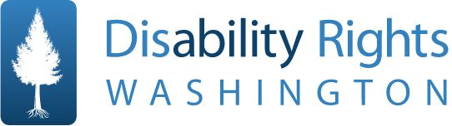
FOR IMMEDIATE RELEASE

Media Contact:
Stacie Siebrecht, Director of Treatment Facilities
(800) 562-2702 ● stacies@dr-wa.org ● disabilityrightswa.org

ANNOUNCING 2018 ‘BREAKING BARRIERS’ AWARD WINNERS
Disability Rights Washington will present a special Lifetime Achievement Award, as well as three
annual honors, to advocates and a business championing Washingtonians with disabilities.

SEATTLE, MAY 31, 2018 — Disability Rights Washington (DRW) presents its prestigious yearly honor to people and businesses that are breaking barriers to improve the lives of Washingtonians with disabilities.

Executive Director Mark Stroh says, “DRW’s mission is to advance the dignity, equality, and self-determination of people with disabilities, and we cannot do this work alone. So we honor others in our community who also worked tirelessly to break down the barriers that hold people with disabilities back.”
- Advocacy Award: Shaun Bickley
Shaun introduced a proposal to end paying disabled workers in Seattle a subminimum wage, building a coalition that didn’t rest until Seattle became the first City government in America to ban the practice. Shaun has also prioritized anti-bias training while Co-Chair of the Seattle Disability Commission.
- Public Policy Award: Representative Roger Goodman
Representative Goodman is honored for his ongoing work in the Washington State Legislature, and beyond, to divert people with disabilities away from the criminal justice system, and for his efforts to improve the lives of the people impacted by that system, including people with disabilities.

- Business Leader Award: MOD Pizza
DRW celebrates MOD Pizza for building an inclusive community by employing a diverse workforce that includes people with all abilities, previously incarcerated people, and people with no job history or who are seeking re-entry to the workforce.
- Lifetime Achievement Award: Marie Jubie
This special award is presented to its inaugural recipient, Marie Jubie, for her lifetime of passion, dedication, and commitment to bettering the lives of people with disabilities, and for ensuring that policymakers understand the real, personal impact of their political decisions.

Disability Rights Washington thanks these leaders for their exhaustive and creative efforts to advance the rights of Washingtonians with disabilities, and looks forward to honoring them at its Breaking Barriers event on September 29, 2018 at the Panorama Room at the Pacific Tower in Seattle, from 5 - 7:30 PM.
For more information, visit https://www.disabilityrightswa.org/breaking-barriers-awards/
To purchase tickets to the Awards, visit https://disabilityrightswa.ejoinme.org/breaking_barriers
Disability Rights Washington (DRW) is a private non-profit organization that protects the rights of people with disabilities statewide. Our mission is to advance the dignity, equality, and self-determination of people with disabilities. We work to pursue justice on matters related to human and legal rights.
###

